(Approx. 1577 words)

President's Corner
Educating My Phone - Graduating to a Smartphone
by Greg Skalka, President, Under the Computer Hood User Group, CA
July 2017 Drive Light
www.uchug.org
president (at) uchug.org

Though I have built many computers over the years, and used and experimented with lots of technology, for the longest time I have resisted getting the one tech item that now seems to be pervasive in our society - a smartphone. I’ve had mobile phones, but only “dumb” cell phones. I’ve had flip phones that could only place voice calls, and a slide phone that allowed talking and texting, but until recently I’d resisted getting a phone that provided access to the internet. Now at last I am “graduating” to a true smartphone.

Now I’m not opposed to technology. I am an electrical engineer by profession, and currently work for a company designing digital radio systems that may be used to connect cell phone towers to the phone network. I have used computers since before the original IBM PC-XT. I have owned and used all manner of computers, laptops, tablets, Chromebooks, music players, GPS receivers and digital cameras and video recorders. I pay for a mobile phone plan that covers three smartphones (my wife and daughter have iPhones, my son has a Google Nexus), but I’ve never graduated from my dumb phone. Until now.

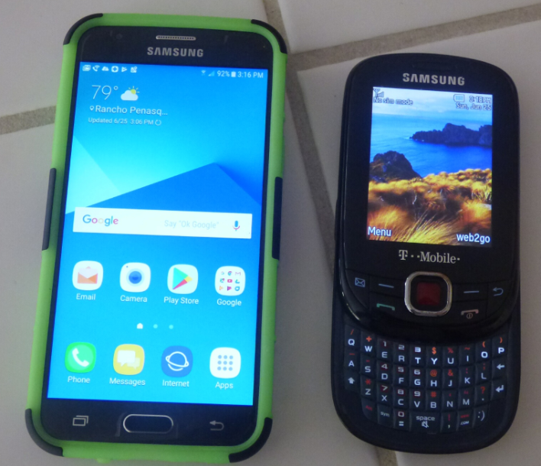
There are a lot of reasons I’ve held back until now. I’m pretty value-conscious (some would say cheap) and for a long time I felt having a smartphone was not worth the cost - mainly in the cost of the phone plan. When data plans were around $40 a month, and my home broadband internet service was about the same, it made me wonder why I had to pay twice; once to have internet access at home, and again to have it away from home. The phones themselves are what I would consider pretty pricey as well. While none of the computers that I use today (desktop or laptop) cost me more than $500, this appears to be about the median price for smartphones.

While the capabilities of smartphones are impressive, the cultural phenomenon of the smartphone is not (at least to me). I really would like to be able to access the internet from practically anywhere, and look with a bit of envy at those searching the web and getting real-time traffic information while out and about. To scan a product bar code in a store and then search the web for additional information, alternatives and better pricing is very powerful. I don’t feel a great need to have my emails with me wherever I go, however; I think being able to communicate via text messaging is plenty good.

For all the good that smartphones represent, I believe there definitely is a dark side. It seems almost everyone has a smartphone, and many can’t seem to put them down. Opioid drugs are very useful in pain treatment, but when abused, they can be very addictive, and ultimately destructive. I see the same things in smartphones - a great and useful tool that has the potential for great abuse. Now maybe great abuse on an individual scale is uncommon, but I worry what these devices are doing to our society. I all too often see families seated at a table in a restaurant, with each family member devoting their full attention to their own smartphones rather than each other. My wife suffers from motion sensitivity and so does the driving whenever we travel together; this gives me the opportunity to observe the drivers in the cars around us. I’ve found it is not unusual to see half of those drivers holding their phones while driving, presumably talking, texting or worse. Unlike laptop computers, smartphones have had traffic deaths attributed to their use, and laws enacted to hopefully prevent their use in situations like driving, where the distraction could be dangerous.

While I was concerned about the added cost, part of my reluctance to getting a smartphone was my desire to not risk becoming “one of them.” those zombie-like people that can’t put their phones down. I never want to ignore those I am with in deference to these little electronic gizmos, or risk stepping out in front of an oncoming car because I’ve tuned out everything but that little device in my hand. Stephen Hawking and Elon Musk are smart guys, and they have both expressed concerns about the potential threat to the human race that artificial intelligence could pose if its development continues. In the same way, I fear we are well on our way to trading away our humanity for these addictive little handheld screens.

So, what made me change my mind and submit to the dark side of smartphones? Is it similar to the argument that “it’s not guns that kill people, but people that kill people”? I do hope (and believe) I can ignore their siren song and not use a smartphone in an overtly antisocial manner.

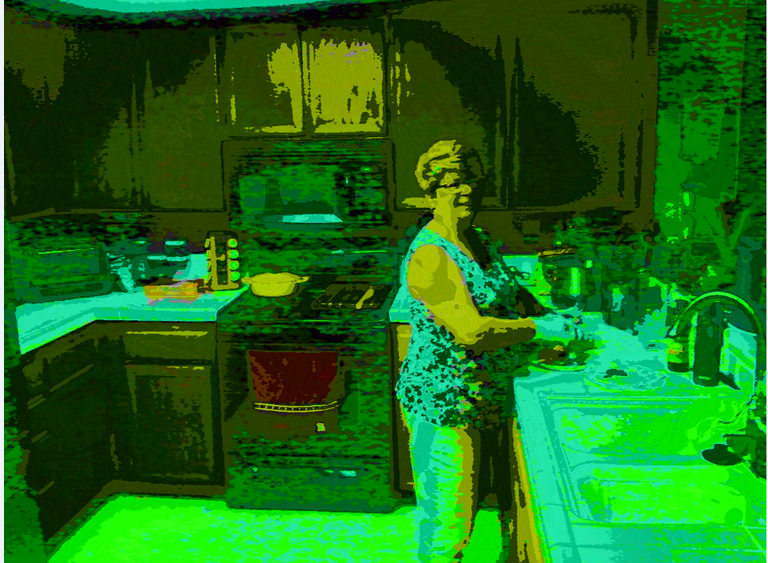
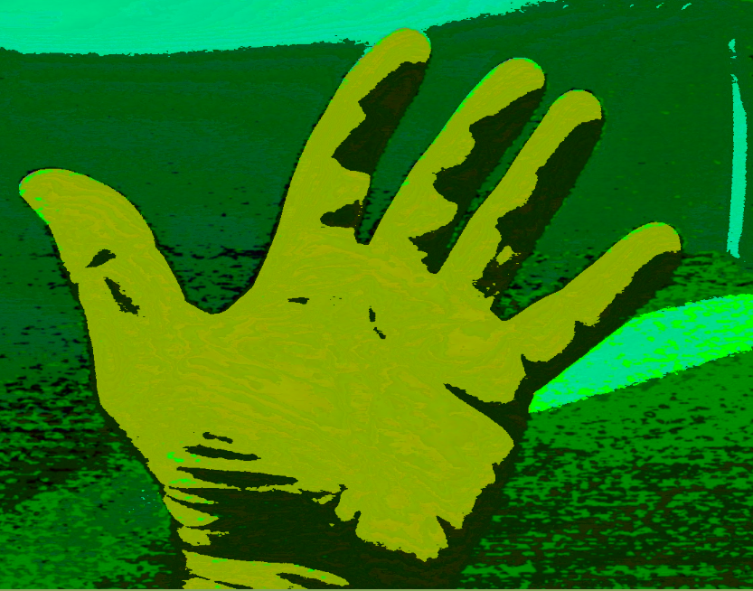
In the end, several factors conspired to put a smartphone in my hand (unlike my slide phone, it is too big for my pocket). Though my slide phone served me well for many years, it has started to become unreliable. Though its built-in camera is poor by current digital camera standards, I found it very handy simply because it was almost always with me. I became dependent on its ability to photograph store product tags for items I wanted to research, and send photos of what I’m doing to my kids. Recently, however, it had started to fail me, more often than not taking photos that look like they were taken in Andy Warhol mode (colorful and cartoonish). Finally, attempts to use the phone camera were greeted with the screen message “Camera not available.” It was not the lack of the internet; it was the lack of a camera that pushed me over the edge.

At the same time, I found that phone plans have changed, with data included in our current T-Mobile family plan for each of us, whether we were using it or not. With extra charges for data overages replaced with data throttling when your monthly limit was reached, my concerns over an increasing bill were eliminated. I had been reluctant to change to a smartphone as I thought it would result in a bigger bill due to adding a data plan for it. As it turned out, I had been entitled to use over 2 GB of mobile data all along (and had only been using a few MB of data sending photos with my slide phone). I had the power to have a smartphone all along; all I had to do was click my heels together in the T-Mobile store (so to speak).

With my slide phone broken and data available in my phone plan, the only remaining issue to graduating to a smartphone this June was the device. Since my needs were modest, I expected the price to be modest as well. I consulted with my son, also an electrical engineer, on his choice for a smartphone, but found he had just copied a more knowledgeable friend when he bought his Google Nexus off the web. I looked on Amazon for unlocked smartphones and found promising candidates in the $120 to $170 price range, but concerns about being able to use these on our plan had me look at the T-Mobile web site. The best candidate seemed to be a Samsung Galaxy J3 Prime, which could be bought outright for $150.

Heading with my wife to the T-Mobile store (the phone account is in her name), I felt kind of like a vegan heading to In ‘N’ Out for a Double-Double, or a diabetic heading to the candy store. Like the recipient of a mail-order bride, I was filled with both excited anticipation and apprehension. Having a smartphone would allow me to do many things I had only dreamed of, like get answers to questions myself when out, rather than have to ask my wife to look things up on her phone. I could get apps and do fun things like check on traffic and control lights at home. Having a smartphone might change me, however. I might become antisocial. I’d have to find a way to carry this larger object and avoid breaking it or losing it. Would I be satisfied with what I had or want more?

At the T-Mobile store, I was able to have my contacts and my few feeble photos transferred from my slide phone to my new smartphone. They took out the 16GB micro SD card from my old phone and put it in my new phone, but I immediately began plotting to get a much larger SD card for the smartphone. I looked at cases for my new phone at the T-Mobile store but they all seemed expensive. I was able to get a nice case with belt clip (my initial experiment with carrying the phone) for a lot less. I didn’t take the phone out much until I’d gotten the case, as I was concerned about damaging it. This caution proved to be justified, as I’ve already dropped the smartphone in the Fry’s parking lot once (but the case protected it).

Now I’ve moved into the 21st century, joining the over 3 billion humans that use smartphones. The phones may be smart - let’s hope all the users remain so.

